RDZGH-200/10 DC High Voltage Generator

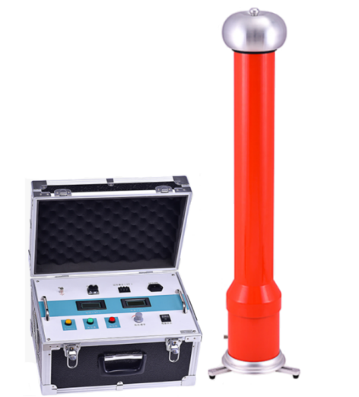
RDZGH-200/10 DC High Voltage Generator adopts new technique, new material and new component with features of high output power, small volume, light weight, etc. And it is with the function of stable over-voltage, over-current, zero position switching protection, 0.75 times voltage latch function, equipped with time relay, can set audio alarm when testing. The whole device is reliable, easy to operate and carry, especially applies to the power department field tests.y.
- Product features
- High precision and accurate measurement. Voltmeter on control cabinet display the voltage applied to load tested equipment. No need to add voltage divider, easy to wire. Equipped with high and low voltage end to measure leakage current. High voltage end adopts round shield digital indication displaying, not worrying discharge shock. It has excellent anti-jam function, which suitable for field operation
- With stable voltage regulation, the regulation is smooth at whole range. The output voltage regulation adopts imported single multiturn potentiometer. Stable boost process and high accurate adjustment
- With negative polarity output, zero start, continuous adjustment, over-voltage, over-current, zero position, grounding protection, special break-line protection functions. It can protect circuit automatically, perfect and reliable protection make safe operation.
- Adopt advanced technology, medium frequency circuit and latest PWM pulse width modulation technology and high power IGBT, which make more stable high voltage output and smaller ripple factor.
- With 0.75 times voltage conversion, convenient to test Zinc Oxide arrester.
- Over-voltage setting use digital dial switch, displaying data directly and visually (unit KV).
- The sampling adopts special nanosecond sensor and nanosecond optical isolation element, which can quickly and completely shut off the DC main circuit to protect the instrument from damage.
- The cylinder adopts new material, light and stable. With 3 support feet at bottom, increase the stability. The outer surface of the cylinder is coated with special insulation materials, good electrical performance, strong moisture capacity, no leakage.
- Case is made of aluminum alloy with small volume, light weight, good appearance, more stable, easy to operate, full function, convenient to use on site.
Product specifications and technical parameters
- Rated Voltage: 200kV
- Rated Current: 10mA
- Rated Power: 2000W
- Weight: 6.5kg + 9kg
- Cylinder Height: 970mm
- Output Voltage Accuracy: ±(1.0%R±2d)
- Output Current Accuracy: ±(1.0%R±2d)
- Ripple Coefficient: ≤0.5%
- Working Mode: Intermittent use, 30 minutes under rated load
- Overload Capacity: No-load voltage can exceed the rated voltage by 10% for 10 minutes; The maximum charging current is 1.25 times the rated current
- Power Supply: AC220V±10%, 50Hz/60Hz
- Working Ambient Temperature: -10~40℃
- Working Ambient Relative Humidity: Not more than 85% at 25℃ room temperature (no condensation)
- Working Ambient Altitude: ＜1500m

